|  |
| --- |
| 新东方在线英语学习 |
| 新概念 3 册 |
| Lesson3 |



扫一扫。更多有趣的英语资讯。



## archaeologist archeologist [ɑ:ki'ɒlədʒi]

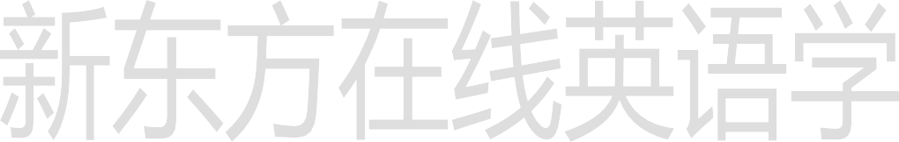**n. 考古学家**archaeology / archeology “arch(a)” = ancient archaic

archaic words archaic civilizations

“(o)logy” = to study -ist“ 人 ” archaeology archaeologist

biology biologist

geology geologist

psychology psychologist

physiology physiologist

anthropology anthropologist

**prosperous ['prɒspərəs] adj.（经济上）繁荣的**

a prosperous country / businessman prosperity economic prosperity

We’ll keep the prosperity and stability of Hong Kong at any cost.

One hundred years later, the Negro lives on a lonely island of poverty in the midst of a vast ocean of material prosperity.

prosper

A company can’t prosper without investment.

thrive / flourish

A company can’t thrive / flourish without investment. plants that thrive / flourish in tropical rainforests

a thriving / flourishing tourist industry

# storey / story ['stɔ:rɪ]

**n. 楼层**

storey → storeys story → stories a two-story house

The house is two stories high.

a multi-story parking lot

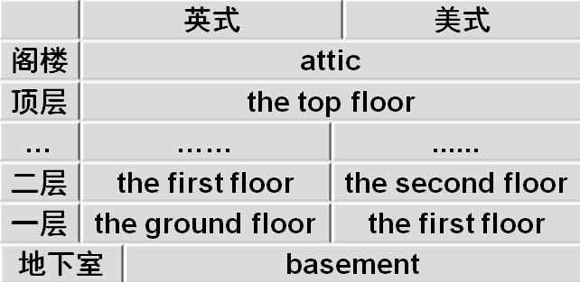floor

# sacred ['seɪkrɪd]

**adj. 宗教的；神圣的**a sacred holiday sacred music

Mecca is a sacred place.

Holy

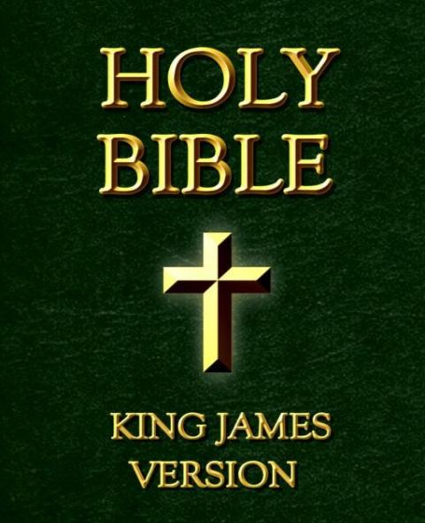

holy water

a holy war blessed

the Blessed Virgin Mary

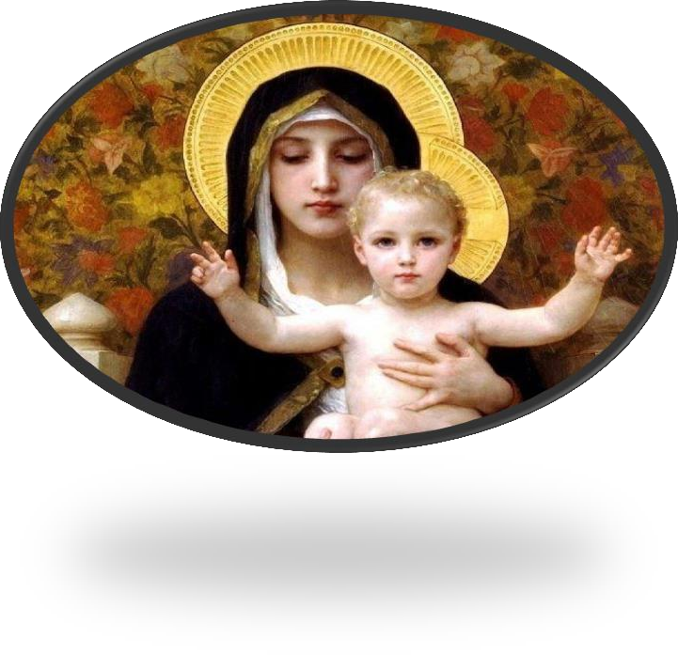

It is more blessed to give than to receive.

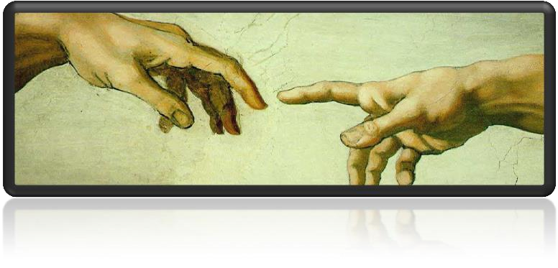

divine

To err is human,to forgive divine.

凡人多舛误唯神能见宥

— Alexander Pope

# remains [rɪ'meɪnz]

**n. 遗物，遗迹，废墟**

the remains of a meal

the remains of ancient Rome

His remains are buried in the churchyard.

the rest of sth.

the remainder of sth. the rest of the semester

= the remainder of the semester what is left of sth.

what remains of sth.

Only two stray dogs benefited from all this confusion, for they greedily devoured what was left of the cake.

It is recounted of Thomas Carlyle that when he heard of the illness of his friend, Henry Taylor, he went off immediately to visit him, carrying with him in his pocket what remained of a bottle of medicine formerly prescribed for an indisposition of Mrs. Carlyle's.

# classical ['klæsikəl]

**adj. 古代（希腊和罗马）文化的**

classical studies

classical music

classic

a classic novel

electric an electric light / razor

electrical electrical failure

historic a historic moment

historical historical records

economic economic policy

economical an economical car

politic a politic decision

political political asylum

# rest [rest]

**v. 倚放，放置**

Her elbows rested on the table.

She rested her head against a cushion.

rest on / upon

Columbus’ decision to sail west rests on his belief that the world is round.

be based / founded on / upon

depend on / upon

rely on / upon

Don’t always **depend** on others. You should learn to rely on yourself.

While the quality of legal journalism varies greatly, there is an undue reliance amongst many journalists on interpretations supplied to them by lawyers.

While comment and reaction from lawyers may enhance stories, it is preferable for journalists to rely on their own notions of significance and make their own judgments.

make a discovery (of…) discover

make an interesting discovery (of …)

use

make use of …

make the best use of…

He made the best use of his talent.

describe

make a vivid description of …

investigate

make a thorough investigation of …

summarize

make a comprehensive summary of … analyze

make a detailed analysis of …

Some time ago, archaeologists made an interesting discovery on the Aegean island of Kea.

A radio message from the mainland had been received by the ship's captain instructing him to give up the search.

the city of Beijing

the promontory of Ayia Irini

the tiny village of Perachora

the famous monastery of St. Bernard t

he novel of Three Kingdoms X

the novel entitled Three Kingdoms

the movie entitled Da Vinci Code t

he man named / called Vincent

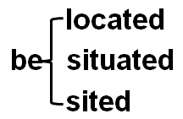an American team of archaeologists

Strange forms stand in gardens, and outside buildings and shops.

The Monument to the People’s Heroes stands in the center of Tian’anmen Square.

sit

The house sits on top of a hill overlooking the town.

lie

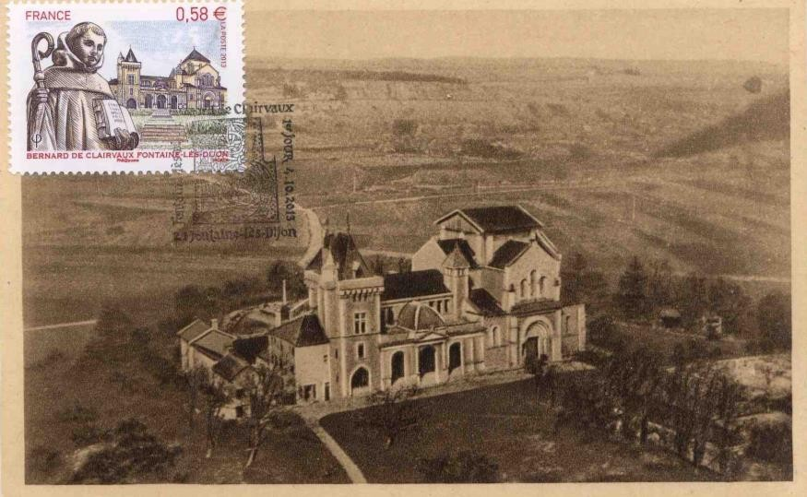The famous monastery of St. Bernard, which was founded in the 11th century, lies about a mile away.

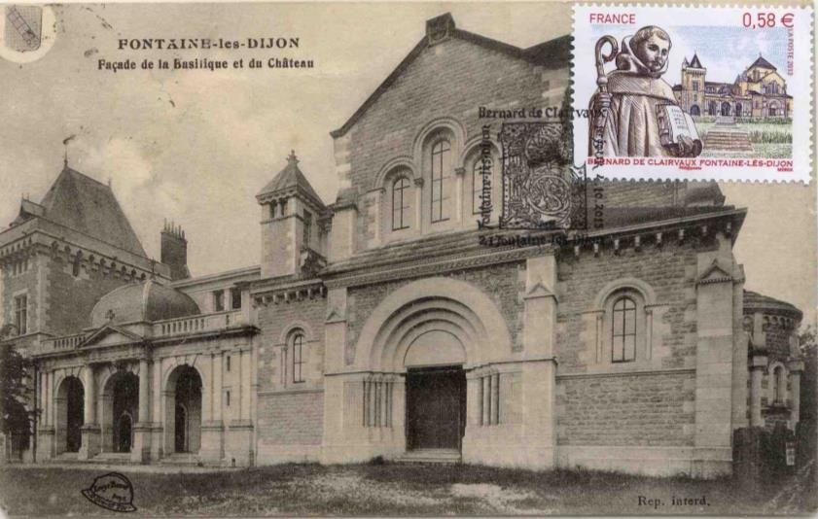

promontory (headland): a long narrow area of high land that sticks out into the sea

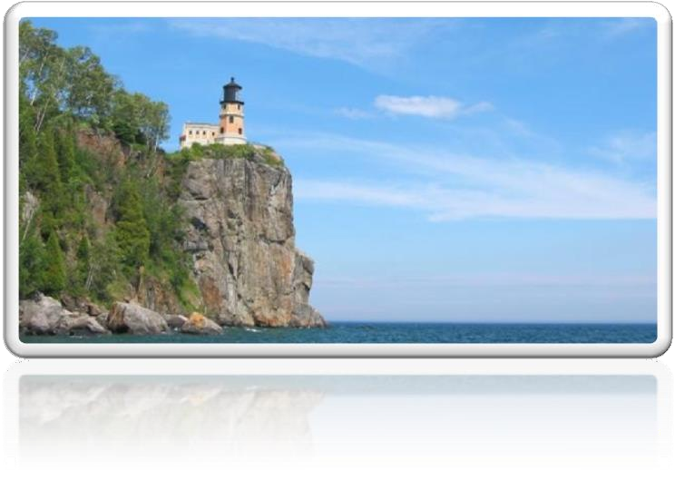

cape: a very large piece of land sticking out into the sea

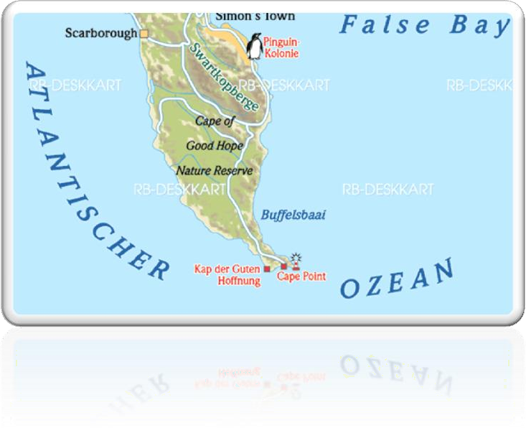

at one time = once

The city at one time must have seen / known prosperity.

enjoy good health

enjoy a high standard of living

The garments are magnificent and tasteful and have long enjoyed great fame both at home and abroad.

be blessed with …

They were blessed with two children, a boy and a girl.

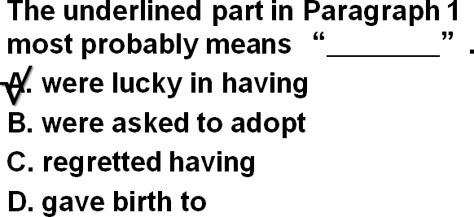

be endowed with …

She is endowed with both brains and beauty.

We hold these truths to be self-evident, that all men are created equal, that they are endowed by the Creator with certain unalienable rights, that among these are life, liberty, and the pursuit of happiness.

― Thomas Jefferson

boast

There is a lot of beautiful scenery in China.

China boasts a lot of beautiful scenery.

a girl with blue eyes

a mug with a broken handle decorate

a vastly improved method

a much acclaimed novel

equip A with B

be equipped with … equipment

The classrooms are equipped with modern multimedia teaching equipment.

a great many (of ) …

a great number of …

a great amount / deal of 不可数 beneath / underneath ➔ on under ➔ over

below ➔ above

The temple which the archaeologists explored was used as a place of worship from the fifteenth century B.C. until Roman times.

be used as …

The wooden box is used as a seat.

act / serve / function as …

The wooden box acts / serves / functions as a seat.

B.C. (BC): Before Christ

A.D. (AD): Anno Domini

|  |
| --- |
| in modern / recent / ancient / prehistoric times  in times of …  in times of peace / war  In times of peace, when business was bad, Hawkwood and his men would march into a city-state …  age  the Ice Age x  the Stone Age  the modern age the computer age  era / epoch  the steam-engine era / epoch the end of an era / epoch  His death marked the end of an era.  the beginning of a new era / epoch  It marked the end of the great tradition of ships with sails and the beginning of a new era.  The foundation of the People’s Republic of China marked the beginning of a new era.  t + j = tʃ don’t you won’t you last year next year situation |

|  |
| --- |
| represent  stand for  Honey, this gold ring stands for / represents my love for you.  on behalf of ...    Premier Li Keqiang delivered a speech on behalf of the Chinese government during the meeting.  Premier Li Keqiang delivered a speech representing / standing for the Chinese government during the meeting. |

|  |
| --- |
| date from … date back to …  can be traced back to …  造句：丝绸之路 (the Silk Road) 的繁荣可以追溯到遥远的汉朝。  The prosperity of the Silk Road dates from / dates back to / can be traced back to the distant Han Dynasty.  happen to do |

|  |
| --- |
| sth. happen to sb.  A car accident happened to him.  happen to do  it happen that …  We happened to take the same train.  It happened that we took the same xftrain. chance to do  it chance that …  We chanced to take the same train.  It chanced that we took the same train.  by chance by accident accidentally  We took the same train by chance / by accident / accidentally.  as it happen  As it happened, we took the same train. |

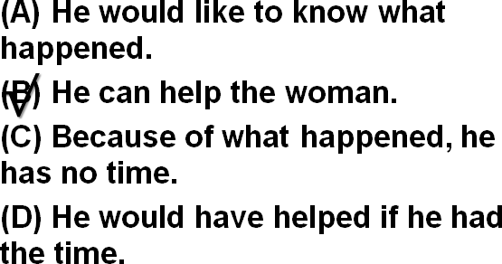

W: I don’t imagine you would have time to help me with this. M: As it happens, I would.

Q: What does the man mean? Answer: (B) He can help the woman. as luck would have it

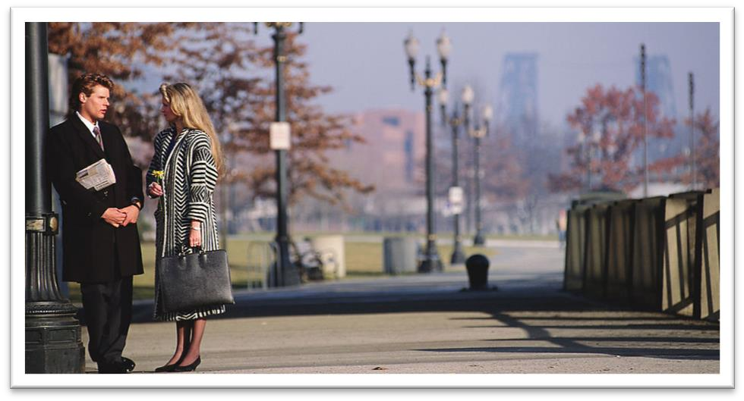As luck would have it, we took the same train.

W: You do look cold. What happened?

M: I've been standing outside in Arctic temperature for over an hour waiting for a bus.

W: Over an hour, but I thought your apartment was only a ten-minute bus ride to campus.

M: Under normal conditions, but the bus was delayed because of the weather and when I stepped into a drugstore to call home for a ride, the bus went by. As luck would have it, there was no one at home, so I had to wait another forty five minutes for the next bus.

W:That's Murphy's law, isn't it. What was it said “If anything can go wrong, it will.” Well, we still get twenty minutes to gather our wits together.

W: You do look cold. What happened?

M: I've been standing outside in Arctic temperature for over an hour waiting for a bus.

W: Over an hour, but I thought your apartment was only a ten-minute bus ride to campus.

M: Under normal conditions, but the bus was delayed because of the weather and when I stepped into a drugstore to call home for a ride, the bus went by. As luck would have it, there was

no one at home, so I had to wait another forty five minutes for the next bus.

W: That's Murphy's law, isn't it. What was it said "If anything can go wrong, it will.” Well, we still get twenty minutes to gather our wits together.

preserve

preserve one’s eyesight / food

conserve

conserve wildlife / resources

reserve

Reserve your energy for the climb tomorrow.

All Rights Reserved

I reserve the right to disagree. reserve a table for 2

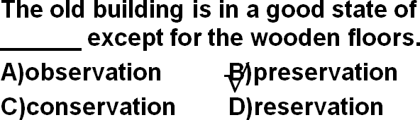

nervous anxious surprise astonish

He was astonished at what he found. A man was lying in the box on top of a pile of woolen goods.

amaze astound

The police were astounded when Mrs. Ramsay told them what she had done.

turn out to be

prove (to be)

Eric’s girlfriend turned out to be his half-sister.

an interesting-looking carved dagger

hard-working easy-going

The tower stands 15 meters 15(high).

weigh

The boy weighs 50 kilos.

measure

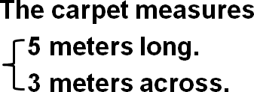



Her hands rested on her hips. Her face rested on her hands.

despite in spite of

notwithstanding

though although

even though while

in spite of the fact that … despite the fact that …

Despite the fact that the bottle is tinted a delicate shade of green, an observant visitor would soon notice that it is filled with what looks like a thick, grayish substance.

如何写出引人入胜的叙事类文章？

制造悬念(有趣发现)→层层深入,迫近主题(古城→庙宇→殿堂→神像)→揭示谜底,故事高潮

(身首异处,摩登女郎)→尾声,意犹未尽(身份未知)